**Supplementary Information**

Angular-Controlled GST Phase-Change Double Micro-Ring Resonator for High-Speed Activation Functions in Neuromorphic Computing

# Hossein Karimkhani1, Yaser M. Banad,1 and Sarah Sharif,1,2,*

1School of Electrical and Computer Engineering, University of Oklahoma, Norman, OK, USA, 73019

2Center for Quantum Research and Technology, University of Oklahoma, Norman, OK, USA, 73019

*Corresponding authors: s[.sh@ou.edu](mailto:.sh@ou.edu)

S1. Transmission Matrix Calculations in Micro Ring Resonators

The transmission matrix calculates the transmission between the rectangular waveguide and ring resonators and can be calculated by (S1) and (S2), according to Figure 1c  [1,2].

$$\begin{aligned}\left[\begin{matrix}E_{mid} \\ E_{1}\end{matrix}\right]=\left[\begin{matrix}t_{1} & {-ik}_{1} \\ {-ik}_{1} & t_{1}^{*}\end{matrix}\right]\left[\begin{matrix}E_{input} \\ E_{2}\end{matrix}\right]\#\left(S1\right)\end{aligned}$$

$$\begin{aligned}\left[\begin{matrix}E_{output} \\ E_{3}\end{matrix}\right]=\left[\begin{matrix}t_{2} & {-ik}_{2} \\ {-ik}_{2} & t_{2}^{*}\end{matrix}\right]\left[\begin{matrix}E_{mid} \\ E_{4}\end{matrix}\right]\#\left(S2\right)\end{aligned}$$

If we consider our system is operating without loss, the relation between coefficients can be calculated by (S3).

$$\begin{aligned}t_{1}^{2}+k_{1}^{2}=t_{2}^{2}+k_{2}^{2}=1\#\left(S3\right)\end{aligned}$$

For simplification $E_{input}$ is equal to 1, and $E_{2}$ can be calculated by the following equation:

$$\begin{aligned}E_{2}=e^{\frac{jω2r_{1}}{c}}E_{1}\#\left(S4\right)\end{aligned}$$

With exploring (S1) and (S4) we can rewrite a new equation for $E_{2}$:

$$\begin{aligned}E_{2}=\frac{{-k}_{1}^{*}}{{-t}_{1}^{*}+e^{\frac{jω2r_{1}}{c}}}\#\left(S5\right)\end{aligned}$$

where, ω is the angular frequency, c is the phase velocity of the ring, and can be calculated by S6

$$\begin{aligned}c=\frac{c_{0}}{n_{eff}}\#\left(S6\right)\end{aligned}$$

Where $c_{0}$ is the speed of the light in vacuum, and $n_{eff}$ is the effective refractive index. Also, ${2r}_{1}$ is the circumference of the ring, and $r_{1}$ is the radius of the first ring resonator. The angular frequency can be calculated by ${kc}_{0}$ where k is the wave number and can be calculated by S7.

$$\begin{aligned}k=\frac{2}{λ}\#\left(S7\right)\end{aligned}$$

Additionally, it is possible to calculate $E_{1}$, $E_{mid}$, $E_{3}$, $E_{4}$, and $E_{output}$ from the following equations.

$$\begin{aligned}E_{1}=\frac{{-k}_{1}^{*}}{1{-t}_{1}^{*}e^{\frac{jω2r_{1}}{c}}}\#\left(S8\right)\end{aligned}$$

$$\begin{aligned}E_{mid}=\frac{-1{+t}_{1}^{*}e^{\frac{jω2r_{1}}{c}}}{{-t}_{1}^{*}+e^{\frac{jω2r_{1}}{c}}}\#\left(S9\right)\end{aligned}$$

$$\begin{aligned}E_{3}=\frac{{-k}_{2}^{*}}{1{-t}_{2}^{*}e^{\frac{jω2r_{2}}{c}}}\#\left(S10\right)\end{aligned}$$

$$\begin{aligned}E_{4}=\frac{{-k}_{2}^{*}}{{-t}_{2}^{*}+e^{\frac{jω2r_{2}}{c}}}\#\left(S11\right)\end{aligned}$$

$$\begin{aligned}E_{output}=\frac{-1{+t}_{2}^{*}e^{\frac{jω2r_{2}}{c}}}{{-t}_{2}^{*}+e^{\frac{jω2r_{2}}{c}}}\#\left(S12\right)\end{aligned}$$

Also, transmission coefficients between output and input can be calculated by (S13) and (S14)  [3].

$$\begin{aligned}T_{output}={\left|\frac{E_{output}}{E_{mid}}\right|}^{2}= \left|\frac{t_{2}e^{A}-\sqrt{e^{-B}}}{t_{2}^{*}e^{A}-\sqrt{e^{-B}}}\right|\#\left(S13\right)\end{aligned}$$

$$\begin{aligned}T_{mid}={\left|\frac{E_{mid}}{E_{input}}\right|}^{2}= \left|\frac{t_{1}e^{C}-\sqrt{e^{-D}}}{t_{1}^{*}e^{C}-\sqrt{e^{-D}}}\right|\#\left(S14\right)\end{aligned}$$

where, $A=-αL_{{rt}_{2}}$ and $C=-αL_{{rt}_{1}}$ are coupling power attenuation. Also, $B=Φ_{{rt}_{2}}$ and $D=Φ_{{rt}_{1}}$ are round-trip optical phase for the first and the second ring, respectively.

S2. Ring Resonator Parameters Calculations

Moreover, the round trip length of the resonance and resonance wavelength can be calculated by Eq. (S15) and (S16)  [3–5].

$$\begin{aligned}L=2(R+L_{c})\#\left(S15\right)\end{aligned}$$

$$\begin{aligned}λ_{r}=Ln_{eff}m^{-1}\#\left(S16\right)\end{aligned}$$

where R represents the radius of the ring, and Lc is the length of the coupling. L and neff show the effective length and effective refractive index respectively. The other important parameters in ring resonators are Full Width Half Maximum (FWHM), Free Spectral Range (FSR), Fitness, and Quality Factor, which can be calculated by Eq. (S17), (S18), (S19), and (S20), respectively  [3,6]. The system with a small FSR denotes that the system can support multiple channels in the proposed wavelength range  [7]. Also, it is important to design two unalike rings to achieve distinct resonant wavelengths  [8].

$$\begin{aligned}FWHM=\frac{c}{nL}arccos\frac{2at_{1}t_{2}}{1+a^{2}t_{1}^{2}t_{2}^{2}}\#\left(S17\right)\end{aligned}$$

$$\begin{aligned}FSR={Wavelength}_{c2}-{Wavelength}_{c1}= Δλ= \frac{λ^{2}}{n_{g}L}\#\left(S18\right)\end{aligned}$$

Where ng is the group refractive index and can be calculated by $n_{eff}-λ\frac{{∂n}_{eff}}{∂λ}$ [3].

$$\begin{aligned}Fit=\frac{FSR}{FWHM}\#\left(S19\right)\end{aligned}$$

$$\begin{aligned}Q Factor=\frac{{Wavelength}_{c}}{FWHM}= \frac{n_{eff}L_{c}}{λ}\frac{\sqrt{at_{1}t_{2}}}{1-at_{1}t_{2}}\#\left(S18\right)\end{aligned}$$

Where c is the speed of the light in free space, n is the refractive index of the waveguide and ring, Wavelengthc2, and Wavelengthc1 are the wavelengths in which the transmission has a peak. The proposed ring resonator has a resonant condition and can be expressed as Eq. (S19)  [1,3].

$$\begin{aligned}2Rn=mλ_{m}\#\left(S19\right)\end{aligned}$$

Where R is the radius of the ring, n is the refractive index of the waveguide, and $λ_{m}$ is the required wavelength.

S3. Summary of GST Material Angular Change Transmission

Table S1 summarizes the results from Figure 3(a–p) at 25 °C. It shows that the minimum Free Spectral Range (FSR) for the proposed structures is 2.86 nm, corresponding to phases three and four, where the GST material has a 0° angular shift in the first ring and a 180° or 270° angular shift in the second ring, respectively. In phases five to sixteen, the transmission coefficients are near zero, and the FSR in all these phases is 3.27 nm. According to Table S1, the best performance is achieved in phase seven, which exhibits a full width at half maximum (FWHM) of 1.18 nm for both resonant wavelengths. The quality factor for this structure is 1,308.212 at resonant wavelengths of 1,543.69 nm and 1,546.96 nm.

Figure S1 illustrates how changing the position of the GST material within the ring resonators affects the transmission coefficient, and Table S2 summarizes these results at 100 °C. In this figure, the transmission coefficient at the waveguide output port is shown for the amorphous GST material. Two distinct resonant wavelengths are observed: the first is associated with the second ring and the second with the first ring.

* Figure S1(a) (Phase 1): The resonant wavelengths are 1,544.10 nm and 1,547.37 nm, with transmission coefficients of 0.159 and 0.0342, respectively.
* Figure S1(b) (Phase 2): The transmission coefficients are 0.211 and 0.423 at the same resonant wavelengths.
* Figure S1(c) (Phase 3): With a 180° angular shift in the first ring, the second resonant wavelength shifts to 1,548.18 nm. The transmission coefficients are 0.0341 for the second ring at this wavelength and 0.418 for the first ring at 1,544.10 nm.
* Figure S1(d) (Phase 4): With a 270° angular shift in the first ring, the first resonant wavelength shifts to 1,544.51 nm. The transmission coefficients are 0.753 for the first ring at this wavelength and 0.061 for the second ring at 1,548.18 nm.

Figures S1(e–h) (Phases 5–8) depict scenarios where the GST material in the second ring has a 90° angular shift:

* Figure S1(e) (Phase 5): The resonant wavelengths are 1,544.92 nm and 1,548.18 nm, with transmission coefficients of 0.100 and 0.00281, respectively.
* Figure S1(f) (Phase 6): With a 90° angular shift in both rings, the resonant wavelengths are 1,545.32 nm and 1,548.18 nm, and the transmission coefficients are 0.174 and 0.194, respectively.
* Figure S1(g) (Phase 7): With a 180° angular shift in the first ring, the resonant wavelengths remain at 1,544.92 nm and 1,548.18 nm, but the transmission coefficients are near zero, specifically 0.033 and 0.034.
* Figure S1(h) (Phase 8): With a 270° angular shift in the first ring, the resonant wavelengths are 1,545.32 nm and 1,548.18 nm, with transmission coefficients of 0.123 and 0.076.

Figures S1(i–l) (Phases 9–12) show cases where the GST material has a 180° angular shift in the second ring. The resonant wavelengths remain at 1,544.92 nm and 1,548.18 nm throughout these phases, and the angular shift of the GST material in the first ring influences the transmission coefficients.

Figures S1(m–p) (Phases 13–16) illustrate scenarios where the GST material has a 270° angular shift in the second ring. Again, the resonant wavelengths are 1,544.92 nm and 1,548.18 nm, and in all these phases, the transmission coefficients are near zero.

A comprehensive summary of all parameters obtained for the sixteen different phases—representing the angular change of the GST material from 0° to 270°—can be found in the Supplementary Information. Table S2 provides detailed results for these phases from Figure S1(a–p) at 100 °C.

Table S1. Summary of all parameters obtained from Figure 3(a–p) at 25 °C for 16 different phases

|  |  |  |  |  |  |  |  |  |  |  |  |
| --- | --- | --- | --- | --- | --- | --- | --- | --- | --- | --- | --- |
| Phase | T1 | T2 | λ1 (nm) | λ2 (nm) | FWHM1 | FWHM2 | FSR | Fit1 | Fit2 | Q1 | Q2 |
| 1 | 0.441 | 0.643 | 1544.1 | 1547.37 | 0.85 | - | 3.27 | 3.847059 | - | 1816.59 | - |
| 2 | 0.423 | 0.645 | 1544.1 | 1547.37 | 0.51 | - | 3.27 | 6.411765 | - | 3027.647 | - |
| 3 | 0.418 | 0.0196 | 1544.1 | 1546.96 | 0.24 | 1.11 | 2.86 | 11.91667 | 2.576577 | 6433.75 | 1391.081 |
| 4 | 0.418 | 0.021 | 1544.1 | 1546.96 | 0.15 | 1.1 | 2.86 | 19.06667 | 2.6 | 10294 | 1403.727 |
| 5 | 0.011 | 0.021 | 1543.69 | 1546.96 | 1.18 | 1.17 | 3.27 | 2.771186 | 2.794872 | 1308.212 | 1319.393 |
| 6 | 0.011 | 0.029 | 1543.69 | 1546.96 | 1.18 | 1.13 | 3.27 | 2.771186 | 2.893805 | 1308.212 | 1366.097 |
| 7 | 0.011 | 0.018 | 1543.69 | 1546.96 | 1.18 | 1.18 | 3.27 | 2.771186 | 2.771186 | 1308.212 | 1308.212 |
| 8 | 0.0106 | 0.0209 | 1543.69 | 1546.96 | 1.17 | 1.13 | 3.27 | 2.794872 | 2.893805 | 1319.393 | 1366.097 |
| 9 | 0.011 | 0.0211 | 1543.69 | 1546.96 | 1.17 | 1.17 | 3.27 | 2.794872 | 2.794872 | 1319.393 | 1319.393 |
| 10 | 0.011 | 0.0297 | 1543.69 | 1546.96 | 1.17 | 1.13 | 3.27 | 2.794872 | 2.893805 | 1319.393 | 1366.097 |
| 11 | 0.0109 | 0.0183 | 1543.69 | 1546.96 | 1.17 | 1.18 | 3.27 | 2.794872 | 2.771186 | 1319.393 | 1308.212 |
| 12 | 0.0106 | 0.0209 | 1543.69 | 1546.96 | 1.17 | 1.13 | 3.27 | 2.794872 | 2.893805 | 1319.393 | 1366.097 |
| 13 | 0.0326 | 0.0210 | 1543.69 | 1546.96 | 1.11 | 1.17 | 3.27 | 2.945946 | 2.794872 | 1390.712 | 1319.393 |
| 14 | 0.0324 | 0.0295 | 1543.69 | 1546.96 | 1.11 | 1.13 | 3.27 | 2.945946 | 2.893805 | 1390.712 | 1366.097 |
| 15 | 0.0323 | 0.0182 | 1543.69 | 1546.96 | 1.11 | 1.18 | 3.27 | 2.945946 | 2.771186 | 1390.712 | 1308.212 |
| 16 | 0.0314 | 0.0208 | 1543.69 | 1546.96 | 1.11 | 1.13 | 3.27 | 2.945946 | 2.893805 | 1390.712 | 1366.097 |

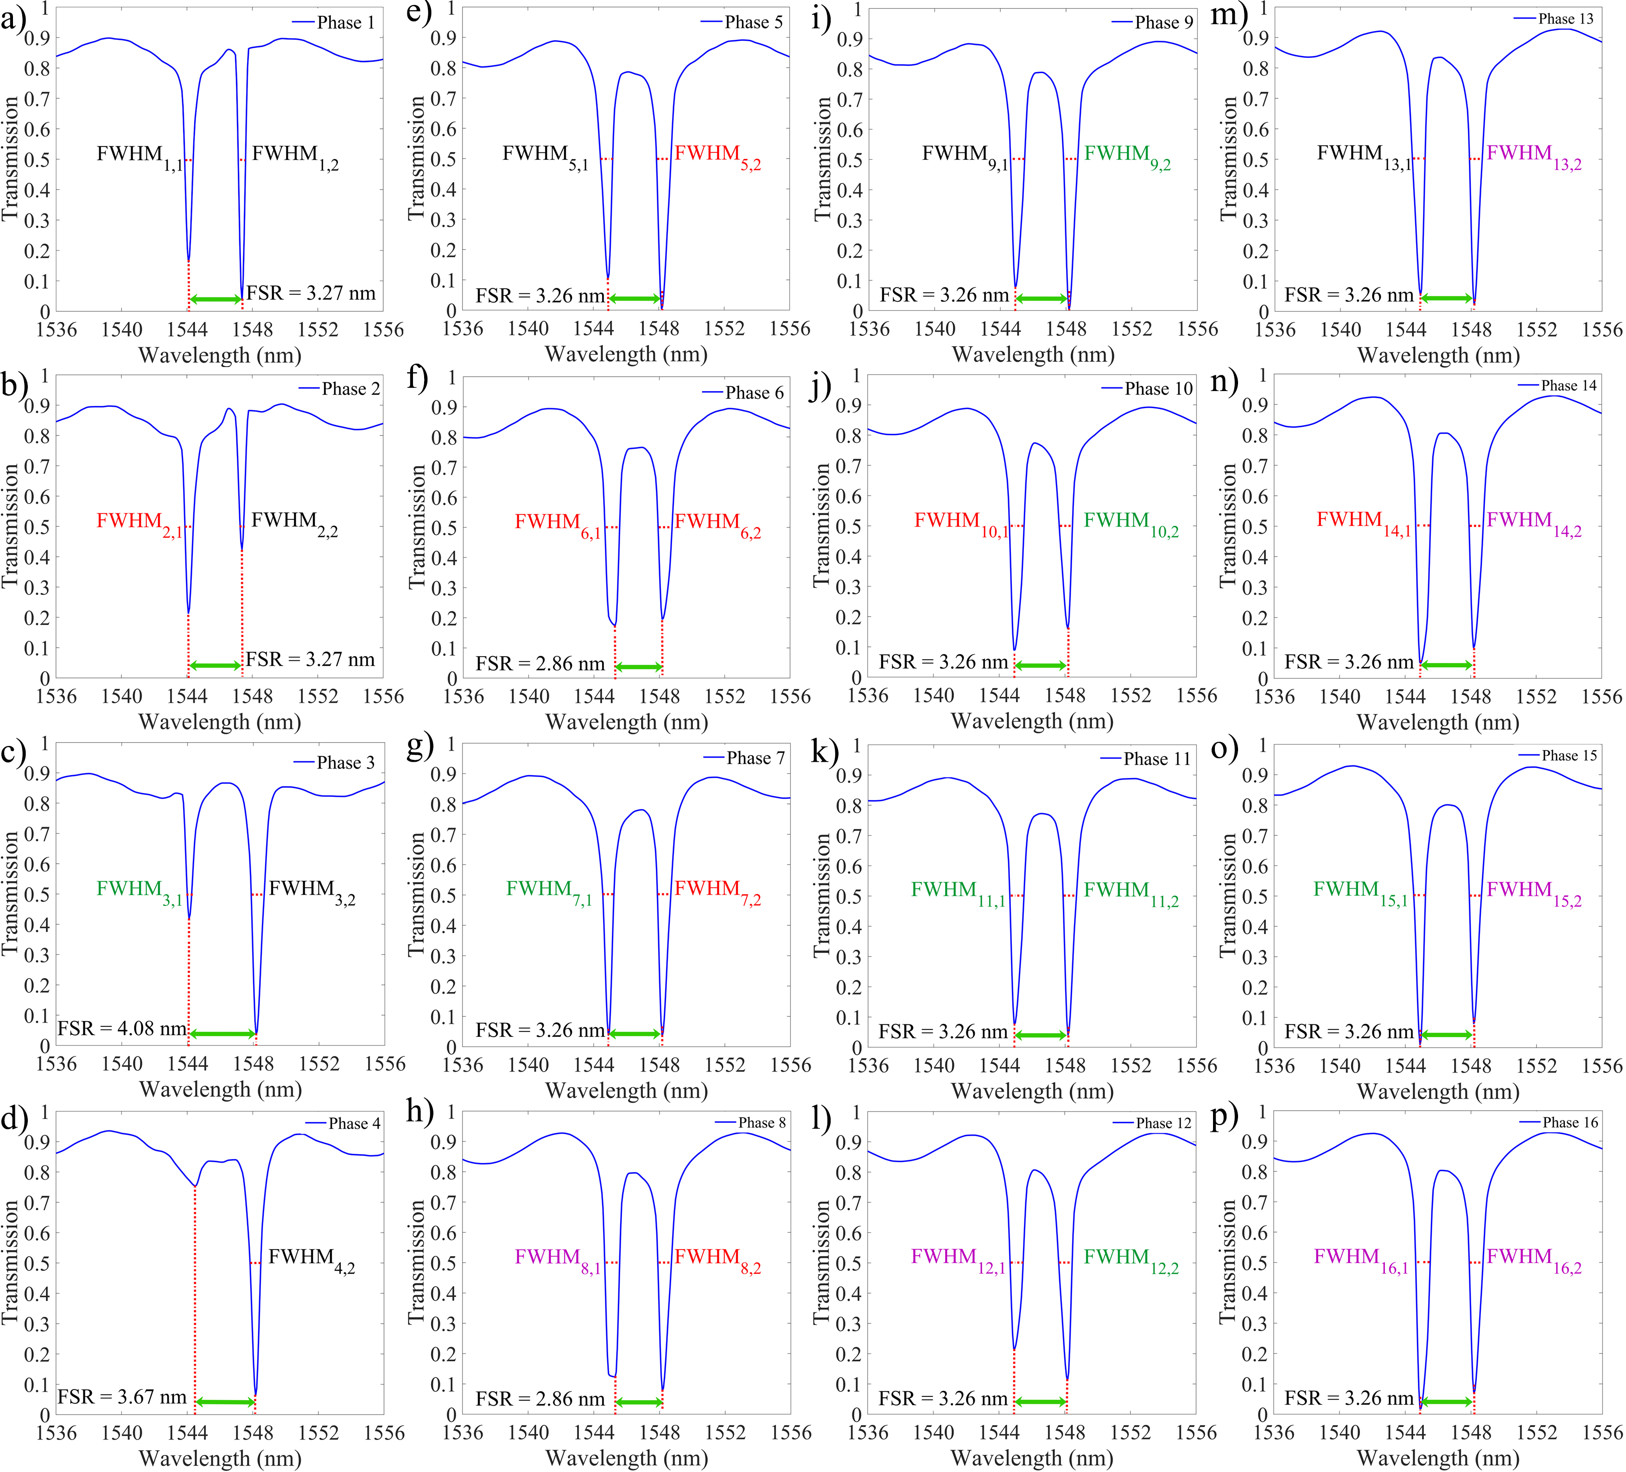

Figure S1. Transmission spectra at the waveguide output port for amorphous GST material in the dual-ring resonator system under sixteen different phase configurations. The plots show two distinct resonant wavelengths: one corresponding to the second ring and the other to the first ring. a-d) The GST material in the second ring has no angular shift, while the first ring exhibits angular shifts of 0°, 90°, 180°, and 270°, respectively. e-h) The GST material in the second ring has a 90° angular shift, with varying angular shifts in the first ring. i-l) The GST material in the second ring has a 180° angular shift, with the angular shift in the first ring varied across the four phases. m-p) The GST material in the second ring has a 270° angular shift, while the first ring's angular shift varies.

Each phase illustrates changes in resonant wavelengths, transmission coefficients, and full-width half-maximum (FWHM), highlighting the impact of GST material angular shifts on optical performance. Table S2, summarizes all of the results from Figure 3a-p) at 100 °C. Table S2 shows that the minimum FSR for the proposed structures is 2.86, which is related to phase six (GST material has 90ᵒ angular shift in both of the rings) and phase 8 (GST material has 90ᵒ and 270ᵒ angular shift in the first and the second ring, respectively). Also, the maximum amount of the FSR is 4.08, which is related to the third phase (GST material has 180ᵒ angular shift in the first ring). According to Table S2, in phases seven, nine, eleven, thirteen, fifteen, and sixteen, transmission coefficients are near zero. The FSR in all of these phases is 3.26. Table S2 demonstrates that the best results are related to phase seven, with 0.7 nm and 0.87 nm full-width half of maximum for the first and the second resonant wavelengths, respectively. Also, the Quality factor for this structure is 2207.02 and 1779.51 at 1544.92 nm and 1548.18 nm resonant wavelengths.

Table S2. Summary of all parameters obtained from Figure S1(a–p) at 100 °C for 16 different phases

|  |  |  |  |  |  |  |  |  |  |  |  |
| --- | --- | --- | --- | --- | --- | --- | --- | --- | --- | --- | --- |
| Phase | T1 | T2 | λ1 (nm) | λ2 (nm) | FWHM1 | FWHM2 | FSR | Fit1 | Fit2 | Q1 | Q2 |
| 1 | 0.159 | 0.0342 | 1544.1 | 1547.37 | 0.85 | 0.47 | 3.27 | 3.84 | 6.95 | 1816.58 | 3292.27 |
| 2 | 0.211 | 0.423 | 1544.1 | 1547.37 | 0.51 | 0.14 | 3.27 | 6.41 | 23.35 | 3027.64 | 1105.64 |
| 3 | 0.418 | 0.0341 | 1544.1 | 1548.18 | 0.19 | 0.82 | 4.08 | 21.47 | 4.97 | 8126.842 | 1888.024 |
| 4 | 0.753 | 0.061 | 1544.51 | 1548.18 | - | 0.67 | 3.67 | - | 5.47 | - | 2310.71 |
| 5 | 0.1 | 0.00281 | 1544.92 | 1548.18 | 0.77 | 0.92 | 3.26 | 4.23 | 3.54 | 2006.38 | 1682.80 |
| 6 | 0.174 | 0.194 | 1545.32 | 1548.18 | 0.91 | 0.86 | 2.86 | 3.14 | 3.32 | 1698.15 | 1800.209 |
| 7 | 0.033 | 0.034 | 1544.92 | 1548.18 | 0.7 | 0.87 | 3.26 | 4.65 | 3.74 | 2207.02 | 1779.51 |
| 8 | 0.123 | 0.076 | 1544.32 | 1548.18 | 0.92 | 0.86 | 2.86 | 3.10 | 3.32 | 1679.69 | 1800.2 |
| 9 | 0.075 | 0.0023 | 1544.92 | 1548.18 | 0.89 | 0.91 | 3.26 | 3.66 | 3.58 | 1735.86 | 1701.29 |
| 10 | 0.0859 | 0.0159 | 1544.92 | 1548.18 | 0.92 | 0.83 | 3.26 | 3.54 | 3.92 | 1679.26 | 1865.27 |
| 11 | 0.0741 | 0.0394 | 1544.92 | 1548.18 | 0.89 | 0.84 | 3.26 | 3.66 | 3.88 | 1735.86 | 1843.07 |
| 12 | 0.214 | 0.109 | 1544.92 | 1548.18 | 0.79 | 0.85 | 3.26 | 4.12 | 3.83 | 1955.59 | 1821.38 |
| 13 | 0.05 | 0.0217 | 1544.92 | 1548.18 | 0.8 | 0.81 | 3.26 | 4.07 | 4.02 | 1931.15 | 1911.33 |
| 14 | 0.0479 | 0.099 | 1544.92 | 1548.18 | 0.92 | 0.89 | 3.26 | 3.54 | 3.66 | 1679.26 | 1739.52 |
| 15 | 0.0067 | 0.077 | 1544.92 | 1548.18 | 0.73 | 0.76 | 3.26 | 4.46 | 4.28 | 2116.32 | 2037.07 |
| 16 | 0.0148 | 0.0677 | 1544.92 | 1548.18 | 0.92 | 0.87 | 3.26 | 3.54 | 3.74 | 1679.26 | 1779.51 |

S4. Transmission Coefficients for the Phase Seven with Different Width for the Second Ring Resonator

Figure S2a shows the transmission coefficients for Phase Seven when the width of the second ring is varied. At a width of 350 nm, the resonant wavelengths are 1545.73 nm and 1548.15 nm, with transmission coefficients of 0.0145 and 0.031, respectively. When the width is increased to 360 nm, the resonant wavelengths shift to 1548.18 nm and 1550.23 nm, with corresponding transmission coefficients of 0.027 and 0.0744. At 370 nm, the resonant wavelengths remain at 1548.18 nm and 1554.76 nm, with transmission coefficients of 0.028 and 0.0011, respectively.

Figure S2d demonstrates that at a width of 380 nm, the resonant wavelengths shift to 1537.61 nm and 1548.18 nm, with transmission coefficients of 0.239 and 0.026. Further increasing the width to 390 nm, 420 nm, and 430 nm results in resonant wavelengths of 1541.32 nm, 1548.15 nm, 1551.1 nm, and 1553.56 nm, with corresponding transmission coefficients of 0.044, 0.0106, 0.007, 0.0805, and 0.303.

Finally, for widths of 440 nm and 450 nm, the resonant wavelengths are 1548.15 nm and 1556.53 nm, and 1537.61 nm and 1548.18 nm, with transmission coefficients of 0.007 and 0.205, and 0.015 and 0.034, respectively. Table S3 summarizes all the results presented in Figure S2a-j, highlighting the impact of varying the second ring width on the transmission and resonance characteristics.

Figure S3a provides a detailed comparison of the first and second transmission coefficients for Phase Seven as the width of the second ring changes from 350 nm to 450 nm. Figure S3b illustrates the first and second FWHM values for the same phase and width range. It can be observed from Figure S3a that the transmission coefficients are lowest at a width of 370 nm, while Figure S3b shows that the best FWHM values are achieved at a width of 400 nm.

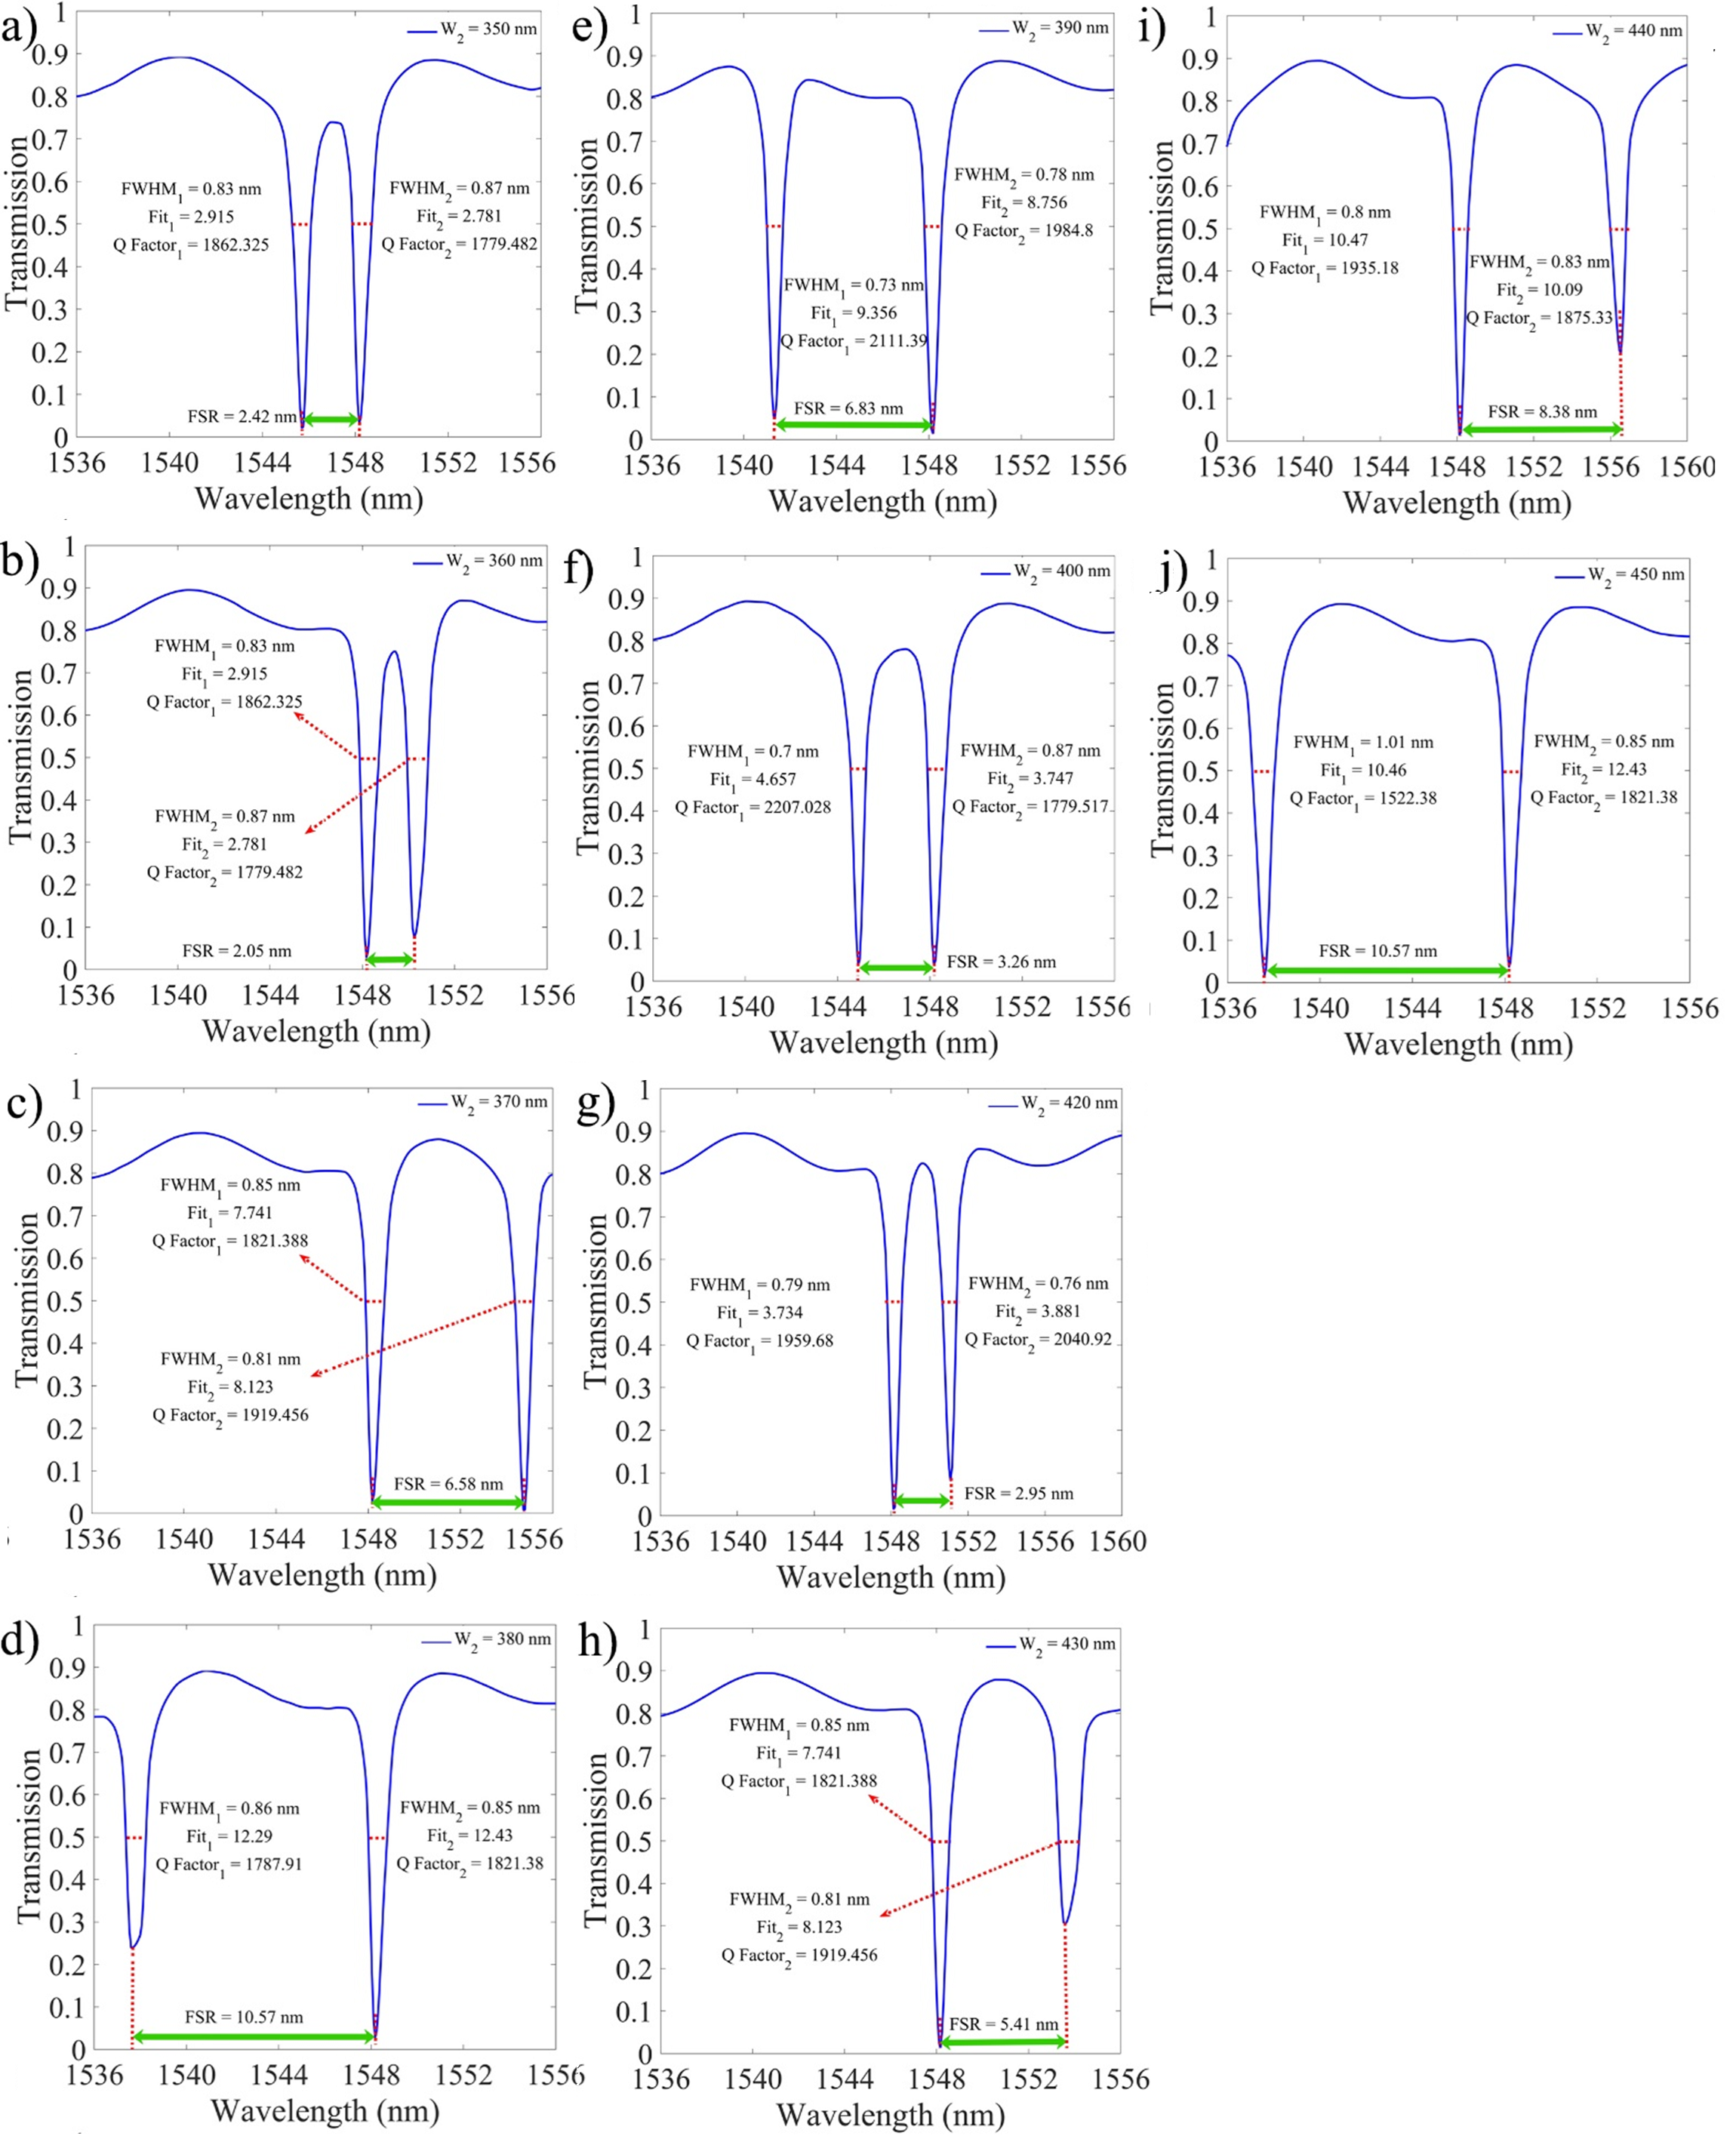

Figure S2. Transmission coefficients for the Phase seven, where the GST material inside the rings has 180ᵒ angular shift in the first ring resonator and 90ᵒ angular shift in the second ring resonator, while the width of the second ring changes from 350 nm to 380 nm. The width of the second ring is a) 350 nm, b) 360 nm, c) 370 nm, d) 380 nm, e) 390 nm, f) 400 nm, g) 420 nm, h) 430 nm, i) 440 nm, j) 450 nm

Table S3. Summary of all parameters obtained from Figure S2(a–j) while the width of the second ring at phase seven changes from 350 nm to 450 nm

|  |  |  |  |  |  |  |  |  |  |  |  |
| --- | --- | --- | --- | --- | --- | --- | --- | --- | --- | --- | --- |
| W2 | T1 | T2 | λ1 (nm) | λ2 (nm) | FWHM1 | FWHM2 | FSR | Fit1 | Fit2 | Q1 | Q2 |
| 350 | 0.0145 | 0.031 | 1547.73 | 1548.15 | 0.83 | 0.87 | 2.42 | 2.915 | 2.781 | 1862.32 | 1779.48 |
| 360 | 0.027 | 0.0744 | 1548.18 | 1550.23 | 0.87 | 0.94 | 2.05 | 2.356 | 2.18 | 1779.517 | 1649.18 |
| 370 | 0.028 | 0.0011 | 1548.18 | 1554.76 | 0.85 | 0.81 | 6.58 | 7.741 | 8.123 | 1821.388 | 1919.456 |
| 380 | 0.239 | 0.026 | 1537.61 | 1548.18 | 0.86 | 0.85 | 10.57 | 12.29 | 12.43 | 1787.918 | 1821.38 |
| 390 | 0.044 | 0.0106 | 1541.32 | 1548.15 | 0.73 | 0.78 | 6.83 | 9.356 | 8.756 | 2111.397 | 1984.807 |
| 400 | 0.033 | 0.034 | 1544.92 | 1548.18 | 0.7 | 0.87 | 3.26 | 4.65 | 3.74 | 2207.02 | 1779.51 |
| 420 | 0.007 | 0.0805 | 1548.15 | 1551.1 | 0.79 | 0.76 | 2.95 | 3.734 | 3.881 | 1959.68 | 2040.92 |
| 430 | 0.01 | 0.303 | 1548.15 | 1553.56 | 0.79 | 0.84 | 5.41 | 6.84 | 6.44 | 1959.68 | 1849.47 |
| 440 | 0.007 | 0.205 | 1548.15 | 1556.53 | 0.007 | 0.205 | 8.38 | 10.47 | 10.09 | 1935.18 | 1875.33 |
| 450 | 0.015 | 0.034 | 1537.61 | 1548.18 | 1.01 | 0.85 | 10.57 | 10.46 | 12.43 | 1522.38 | 1821.38 |

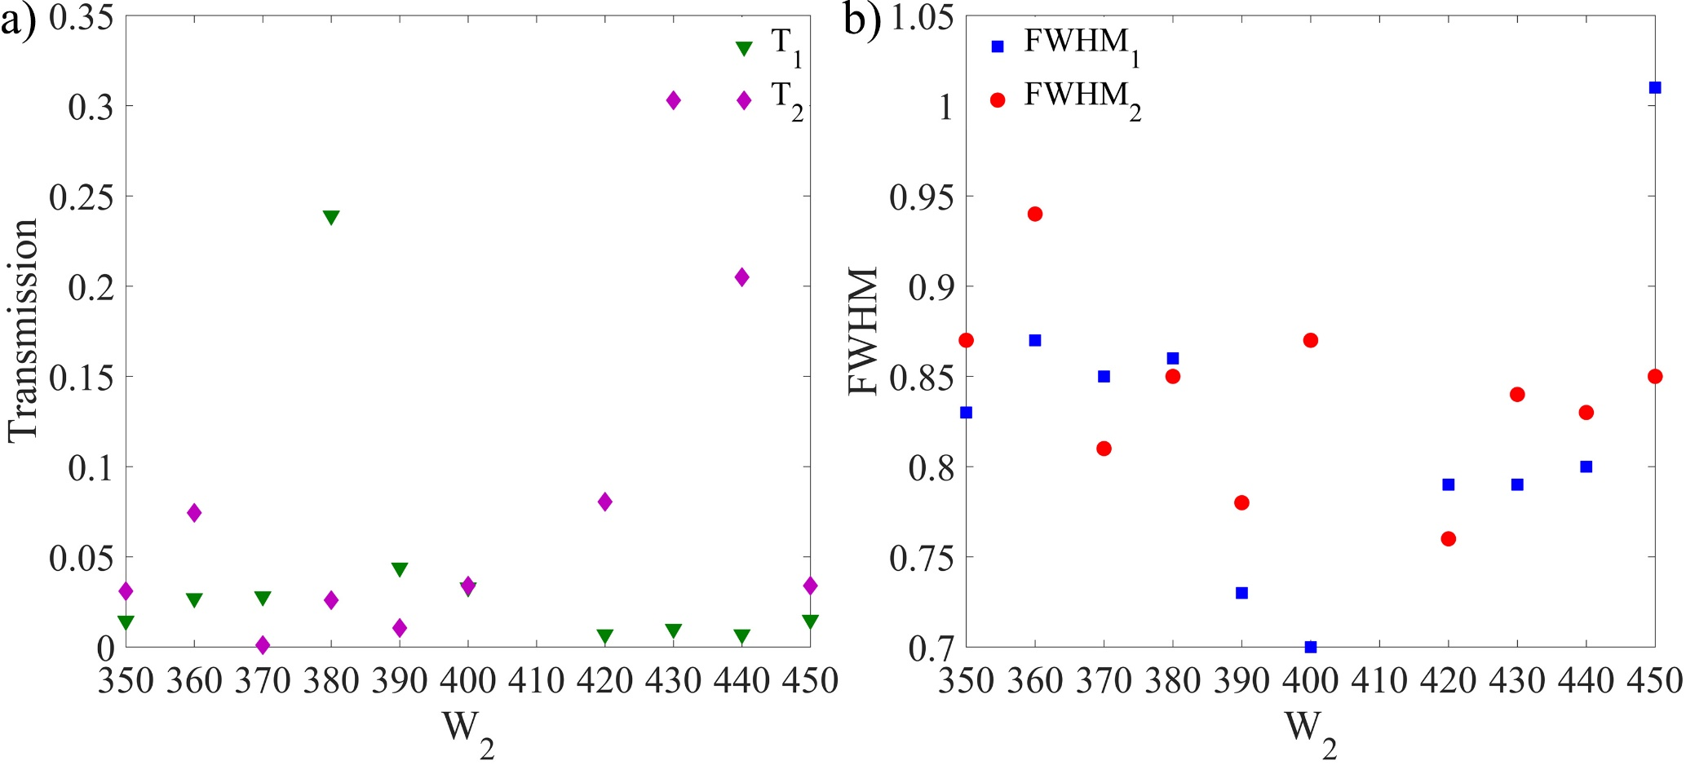

Figure S3. First and second a) transmission coefficient and b) FWHM for the seventh phase while the width of the second ring changes from 350 nm to 450 nm.

S5. Transmission Coefficient for Sixteen Phases at Two Temperatures

Figure S4 illustrates the transmission coefficients for all sixteen phases at 25°C (blue curves) and 200°C (red curves), highlighting the temperature-dependent behaviour of the dual-ring resonator system.

* **Figures S4a-d**: These panels show the transmission coefficients for the first four phases, where the GST material in the second ring has no angular shift, and the first ring has angular shifts of 0°, 90°, 180°, and 270°. In Phase 1 (Figure S4a), the transmission coefficient undergoes a significant change when the temperature increases from 25°C to 200°C, demonstrating a notable response. However, in Figures S4b-d, as the angular shift in the first ring increases, the temperature-dependent changes in the transmission coefficients become broader and less distinct, with shifts of approximately 0.3, which may not be ideal for the proposed application.
* **Figures S4e-h**: These panels represent phases where the GST material in the second ring has a 90° angular shift. In Phase 5 (Figure S4e), the transmission coefficients at 25°C and 200°C remain nearly identical, showing minimal temperature dependence. For Phases 6-8 (Figures S4f-h), the GST material in the first ring has angular shifts of 90°, 180°, and 270°, respectively. While some changes in the transmission coefficients are observed at 200°C, the shifts are relatively minor, with a maximum of around 0.3, and the temperature response remains broad.
* **Figures S4i-l**: These panels illustrate phases with a 180° angular shift in the GST material in the second ring. Across these phases, the transmission coefficients show minimal variation between 25°C and 200°C, indicating weak temperature sensitivity.
* **Figures S4m-p**: These panels show phases where the GST material in the second ring has a 270° angular shift. Similar to the 180° angular shift, the transmission coefficients across these phases display negligible differences between the two temperatures, suggesting limited temperature responsiveness.

Overall, Figure S4 demonstrates that the first phase (Figure S4a), where the GST material has no angular shift in either ring, provides the best temperature response. In this phase, the transmission coefficient exhibits a substantial change from 0 to 0.7 as the temperature increases from 25°C to 200°C. This makes Phase 1 the most promising configuration for applications requiring significant temperature-dependent transmission changes.

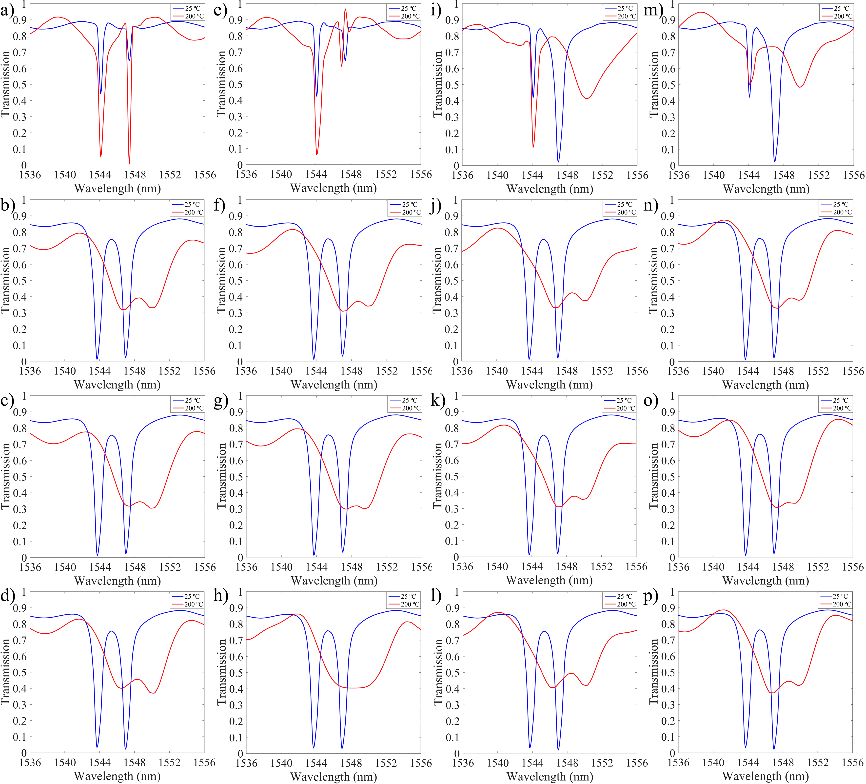

Figure S4: Transmission coefficient for all of the sixteen phases at 25ᵒ C and 250ᵒ C, where the GST materials inside the ring resonators have 0ᵒ to 270ᵒ angular shift.

S6. Electrical Field Distribution for Phase Seven

Figure S5 illustrates the electrical field profile at various wavelengths. Figure S5a) illustrates the first and the second transmission coefficients for the seventh phases while the width of the second ring changes from 350 nm to 450 nm. Figure S4b shows the first and the second FWHM for the seventh phase for various widths of the second ring. Figure S5a) demonstrates that while the width of the second ring is 370 nm, the structure at the seventh phase has the lowest transmission coefficients; however, at 400 nm, it has the best FWHM.

Figure S5 illustrates the electric field distribution and corresponding transmission coefficients at two resonant wavelengths for Phase Seven. In **Figure S5a**, the transmission spectrum shows two distinct resonant wavelengths, λ1=1544.92 nm, and λ1=1548.18 nm, corresponding to the coupling regions in the dual-ring resonator. These wavelengths are highlighted with their respective transmission coefficients, demonstrating the resonator's filtering and coupling behavior. In **Figure S5b, t**his panel shows the electric field profile at λ1=1544.92 nm, where the electric field is strongly confined in **Coupling Region 1**. The energy is primarily concentrated within the first ring resonator, confirming efficient coupling between the input waveguide and the first ring. In **Figure S5c,** the electric field profile at λ1=1548.18 nm highlights strong field confinement in **Coupling Region 2**, which is associated with the second ring resonator. The energy is transferred efficiently between the input waveguide and the second ring, showcasing distinct wavelength-selective behavior. The analysis reveals that the seventh phase provides clear field localization at the resonant wavelengths, enabling selective control of transmission properties. The resonant behavior and field confinement demonstrated in Figure S5 underscore the importance of phase and structural configuration for optimizing transmission performance in the dual-ring resonator system.

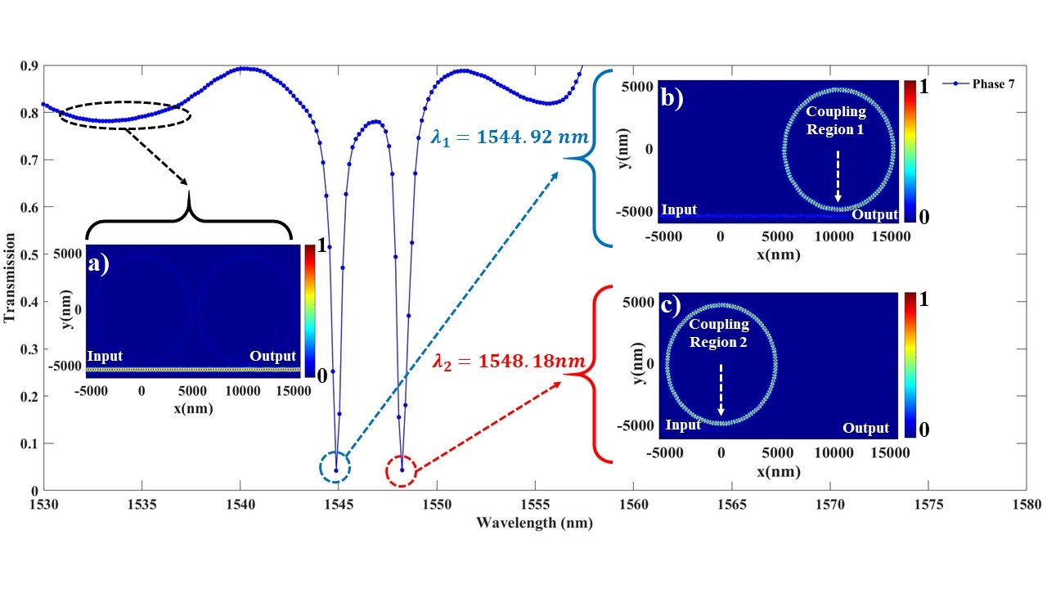

Figure S5. Electrical field distribution for phase seven at a) below 1544.92 nm wavelengths, which go entirely to the output through the port, at b) 1544.92 nm wavelengths, which are entirely confined inside the second ring resonator; and at c) 1548.18 nm wavelengths; which are confined in the first ring resonator.

S7. Refractive index calculations for GST material

The refractive index of the GST material is derived from experimental data provided in Reference [9]. Using this data, the dielectric function of the GST material can be calculated with the following equation:

$$\begin{aligned}ε_{GST}(ω)={(n_{GST}\left(ω\right)+{ik}_{GST}\left(ω\right))}^{2}\#\left(S20\right)\end{aligned}$$

where, $n_{GST}\left(ω\right)$ and $k_{GST}\left(ω\right)$ represent the real and imaginary parts of the GST refractive index, respectively.

Figure S6 shows the variation in the real (*n*) and imaginary (*k*) components of the refractive index for both amorphous (25°C) and crystalline (200°C) states. The data illustrates a notable increase in both n and k as the temperature transitions from 25°C to 200°C across the wavelength range of 700 nm to 1800 nm. The effective permittivity $ε_{eff}\left(ω\right)$ of GST material at different crystallization states can also be calculated using the Lorentz-Lorenz relation [10–12]:

$$\begin{aligned}\frac{ε_{eff}\left(ω\right)-1}{ε_{eff}\left(ω\right)+2}=p\frac{ε_{GST-C}\left(ω\right)-1}{ε_{GST-C}\left(ω\right)+2}+(1-p)\frac{ε_{GST-A}\left(ω\right)-1}{ε_{GST+A}\left(ω\right)+2}\#\left(S21\right)\end{aligned}$$

where $ε_{GST-C}\left(ω\right)$ is the permittivity of the GST material at crystalline state, and $ε_{GST-A}\left(ω\right)$ is the permittivity of the GST material at the amorphous state. Also, p is the crystallization rate of the GST material, which ranges between 0 and 1. While the material is in the crystalline state, p is 1, and while the material is in the amorphous state, p is 0.

**Table S4** summarizes the real and imaginary components of the refractive index (n and k) for the GST material at various wavelengths for both crystalline and amorphous states. Similarly, **Table S5** provides a detailed breakdown of the dielectric function (*ε*1 and *ε*2​) for the GST material at selected wavelengths.

In **Figure S7**, the real and imaginary parts of the dielectric function are plotted for both amorphous and crystalline states over a range of wavelengths. Beyond 800 nm, the difference between the two states becomes more pronounced, with the imaginary part showing significant increases in the crystalline state. This behavior underscores the strong optical contrast achievable by transitioning between the two phases, which is critical for phase-change-based optical devices.

Table S6 summarizes the real (ε1) and imaginary (ε2) part of the permittivity of the GST material for both crystalline and amorphous states, while the energy changes from 0 eV to 3 eV.

Table S4. Refractive index of the GST material. Summary of the real (𝑛) and imaginary (𝑘) components of the refractive index for GST material in its amorphous (25°C) and crystalline (200°C) states at selected wavelengths (255 nm to 1750 nm).

|  |  |  |  |  |  |  |  |  |  |  |
| --- | --- | --- | --- | --- | --- | --- | --- | --- | --- | --- |
| λ (nm) | 255 | 357 | 574 | 785 | 942 | 1110 | 1260 | 1420 | 1590 | 1750 |
| n-cGST | 0.744 | 1.53 | 3.23 | 4.78 | 5.74 | 6.59 | 7.09 | 7.23 | 6.91 | 6.11 |
| k-cGST | 2.49 | 3.29 | 4.2 | 4.32 | 4.08 | 3.58 | 3.02 | 2.4 | 1.86 | 1.5 |
| n-aGST | 1.69 | 2.59 | 3.85 | 4.52 | 4.76 | 4.78 | 4.71 | 4.61 | 4.51 | 4.47 |
| k-aGST | 2.59 | 2.49 | 2.09 | 1.57 | 1.13 | 0.754 | 0.436 | 0.177 | 0.0987 | 0.181 |

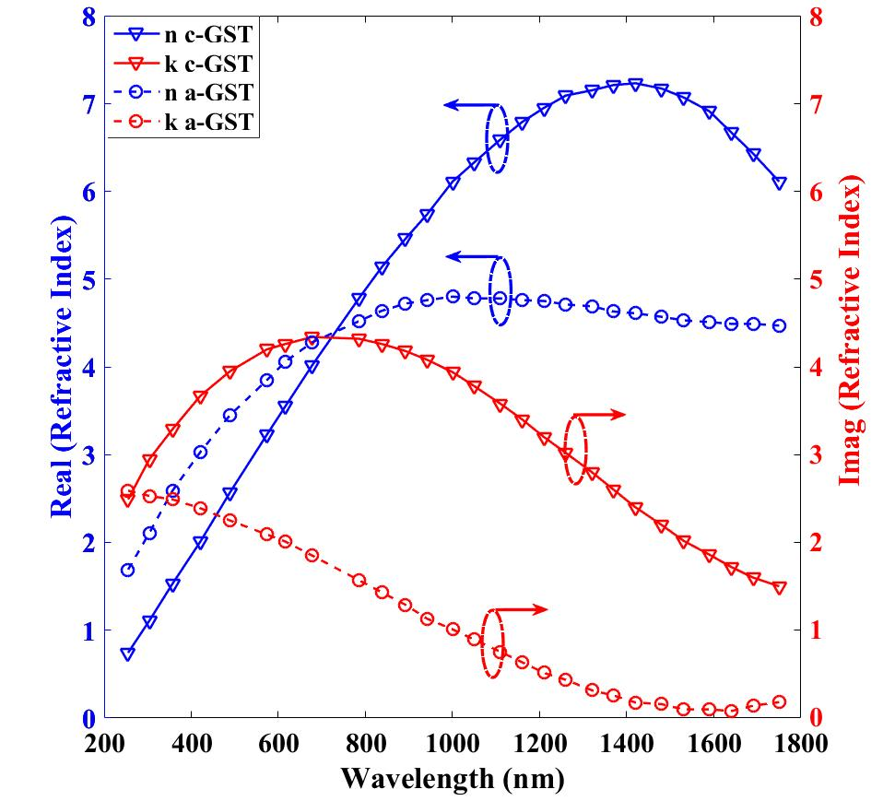

Figure S6. Refractive Index of GST Material. Real (n) and imaginary (k) parts of the refractive index for GST material in amorphous (25°C) and crystalline (200°C) states, plotted across the wavelength range of 700 nm to 1800 nm.

Table S5. Dielectric function of the GST material. Summary of the real (𝜀1) and imaginary (𝜀2) parts of the dielectric function for GST material in its amorphous (25°C) and crystalline (200°C) states at selected wavelengths (255 nm to 1750 nm).

|  |  |  |  |  |  |  |  |  |  |  |
| --- | --- | --- | --- | --- | --- | --- | --- | --- | --- | --- |
| λ (nm) | 255 | 357 | 574 | 785 | 942 | 1110 | 1260 | 1420 | 1590 | 1750 |
| ε1-cGST | -5.64 | -8.48 | -7.20 | 4.18 | 16.3 | 30.61 | 41.15 | 46.51 | 44.29 | 35.08 |
| ε2-cGST | 3.70 | 10.07 | 27.13 | 41.3 | 46.84 | 47.18 | 42.82 | 34.7 | 25.71 | 18.33 |
| ε1-aGST | -6.15 | -3.85 | 6.065 | 20.38 | 31.67 | 42.86 | 50.08 | 52.24 | 47.74 | 37.3 |
| ε2-aGST | 3.85 | 7.61 | 13.5 | 15.01 | 12.97 | 9.93 | 6.18 | 2.55 | 1.36 | 2.21 |

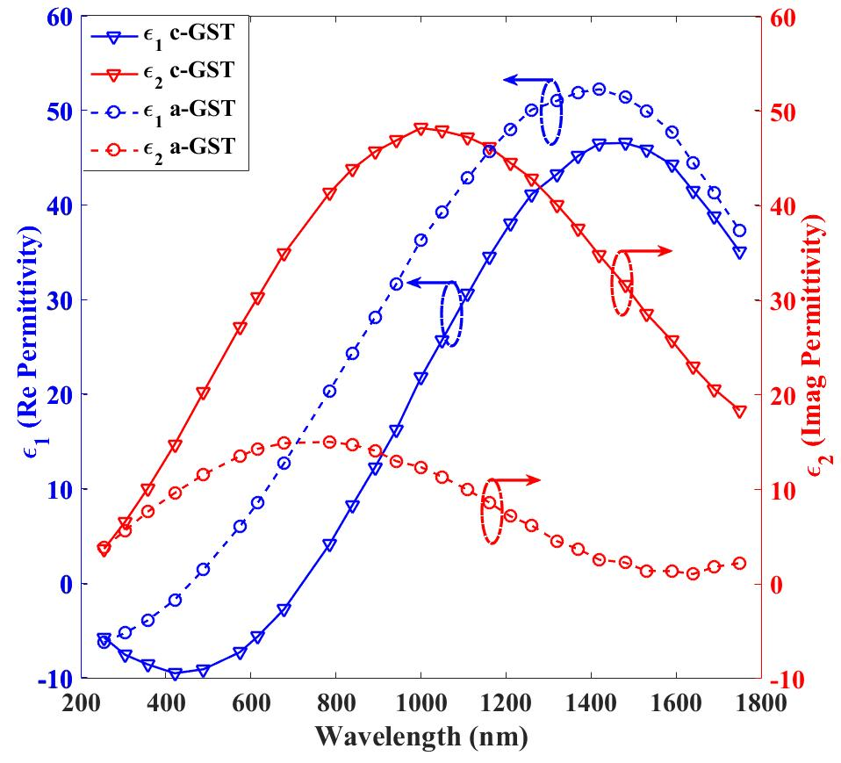

Figure S7. Dielectric Function of GST Material. Real ($ε_{1}$) and imaginary ($ε_{2}$) parts of the dielectric function for GST material in amorphous (25°C) and crystalline (200°C) states, plotted across the wavelength range of 700 nm to 1800 nm.

Table S6. Comprehensive summary of parameters for 16 different phases of GST, representing angular changes from 0° to 270° in the dual-ring resonator system.

|  |  |  |  |  |  |  |  |  |  |  |
| --- | --- | --- | --- | --- | --- | --- | --- | --- | --- | --- |
| Energy (eV) | 0 | 0.5 | 0.75 | 1 | 1.5 | 2 | 2.26 | 2.5 | 2.75 | 3 |
| *ε*1cGST | 32.8 | 45.2 | 45.7 | 33.1 | 3.78 | -7.08 | -8.45 | -8.65 | -8.35 | -7.67 |
| *ε*2cGST | 12.7 | 6.83 | 25.4 | 39.2 | 38.2 | 24.7 | 19.3 | 15.4 | 12.3 | 9.87 |
| *ε*1aGST | 15.7 | 17.5 | 19.9 | 21.9 | 18.7 | 9.57 | 5.45 | 2.87 | 0.84 | -0.34 |
| *ε*2aGST | 0 | 0 | 1.32 | 5.43 | 14.9 | 18 | 17.1 | 14.9 | 13.3 | 11.5 |

References

1. L. Cai, Y. Lu, and H. Zhu, "Performance enhancement of on-chip optical switch and memory using Ge2Sb2Te5 slot-assisted microring resonator," Opt. Lasers Eng. **162**, 107436 (2023).

2. F. Bo, Ş. K. Özdemir, F. Monifi, J. Zhang, G. Zhang, J. Xu, and L. Yang, "Controllable oscillatory lateral coupling in a waveguide-microdisk-resonator system," Sci. Rep. **7**, 8045 (2017).

3. D. G. Rabus, "Integrated ring resonators," (2007).

4. E. Adibnia, M. A. Mansouri-Birjandi, M. Ghadrdan, and P. Jafari, "A deep learning method for empirical spectral prediction and inverse design of all-optical nonlinear plasmonic ring resonator switches," Sci. Rep. **14**, 5787 (2024).

5. M. A. Swillam, A. O. Zaki, K. Kirah, and L. A. Shahada, "On chip optical modulator using epsilon-near-zero hybrid plasmonic platform," Sci. Rep. **9**, 6669 (2019).

6. Y. Long and J. Wang, "Optically-controlled extinction ratio and Q-factor tunable silicon microring resonators based on optical forces," Sci. Rep. **4**, 5409 (2014).

7. G. Gao, Y. Zhang, H. Zhang, Y. Wang, Q. Huang, and J. Xia, "Air-mode photonic crystal ring resonator on silicon-on-insulator," Sci. Rep. **6**, 19999 (2016).

8. H. Chandrahalim and X. Fan, "Reconfigurable solid-state dye-doped polymer ring resonator lasers," Sci. Rep. **5**, 18310 (2015).

9. H. J. Kim, J. Sohn, N. Hong, C. Williams, and W. Humphreys, "PCM-net: a refractive index database of chalcogenide phase change materials for tunable nanophotonic device modelling," J. Phys. Photonics **3**, 24008 (2021).

10. G. Linyang, M. Xiaohui, C. Zhaoqing, X. Chunlin, L. Jun, and Z. Ran, "Tunable a temperature-dependent GST-based metamaterial absorber for switching and sensing applications," J. Mater. Res. Technol. **14**, 772–779 (2021).

11. P. Grahn, A. Shevchenko, and M. Kaivola, "Electromagnetic multipole theory for optical nanomaterials," New J. Phys. **14**, 93033 (2012).

12. W. Zhu, Y. Fan, C. Li, R. Yang, S. Yan, Q. Fu, F. Zhang, C. Gu, and J. Li, "Realization of a near-infrared active Fano-resonant asymmetric metasurface by precisely controlling the phase transition of Ge 2 Sb 2 Te 5," Nanoscale **12**, 8758–8767 (2020).